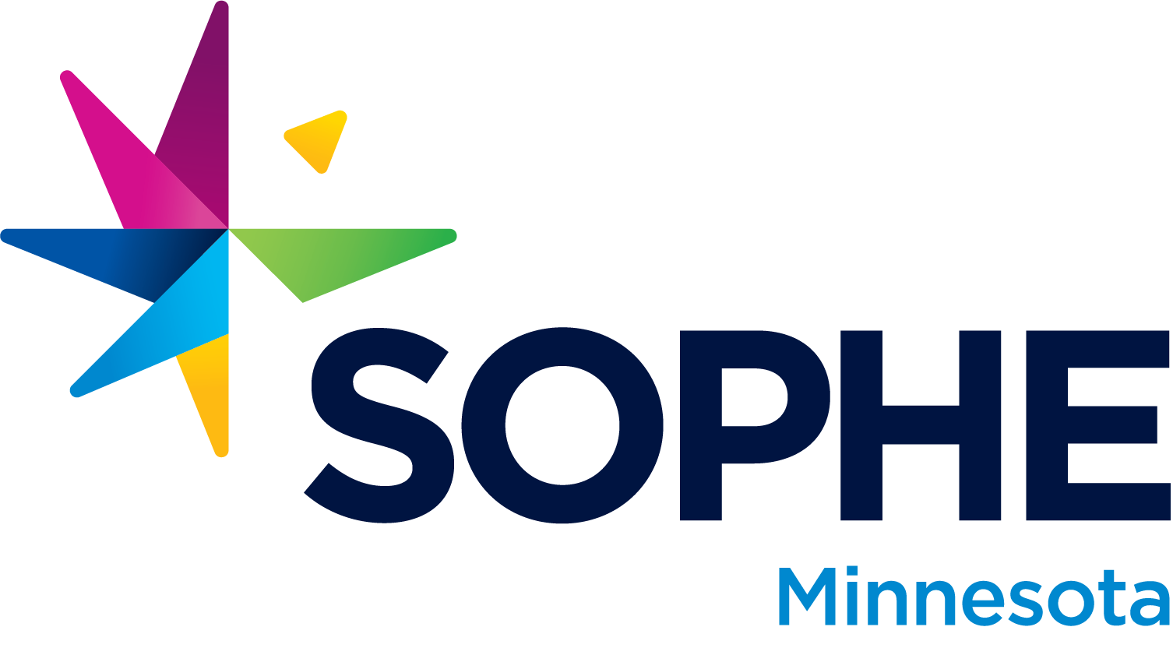
May 2022 Agenda

MNSOPHE MN SOPHE Board Meeting of the Executive Committee and Officers

Date: Friday, May 20, 2022, 1:00-2:30
Meeting Link: https://minnstate.zoom.us/j/97961744536
Meeting ID: 979 6174 4536

Board Google Main Folder

AGENDA

Call to order & approval of agenda – Mary

Roll call- Jean

Introductions & Welcome to Lauren Witt, attending, interested in Advocacy Chair role

Old Business
- Approval of April 2022 Minutes
- 2022 Goals
- Explore process and documents needed for becoming a 501(c)(3) organization
- Establish student scholarship awards – Student scholarship ($250?) + Advocacy Summit
- Explore partnering opportunities with other organizations
- Professional development offerings quarterly
- Establish plan for marketing the value of health educators
- MOU for Assistance with CHES credits- MPHA https://docs.google.com/document/d/1hfW9X5iYcQvc6CMtRSN88zL9kSPpFPM-/edit?usp=sharing&ouid=102372305426061623481&rtpof=true&sd=true

- Request from Iowa SOPHE - Updates from meeting with Dr. Erica Thomas - Mary

New Business
  - Officer and Committee Reports (move Liz up?)
- President Report –Mary
- A HUGE Kudos to Cat and reviewers - MPHA conference
- Current Health education faculty roster - anyone have updates?
- https://docs.google.com/spreadsheets/d/1mCvruOrElN8UFcz7ZSswpglxwPvyDgYd/edit?usp=sharing&ouid=102372305426061623481&rtpof=true&sd=true
- Secretary’s Report – Jean
- Past-president Report –Kelly
- President-elect Report, update on HES - Liz
- Student Representative Report - Kenia and Katie
-Treasurer Report—Cherylee -
- Advocacy Report –
- Communications - Sia
- Posting schedule:
  - MWF - Posts and stories in the afternoon on FB and IG
  - Weekends - Liking/following other pages/organizations
  - Every other Friday - Email updates/jobs opportunities to google group
- Most popular post: Member Highlight (321 reached on FB)
- In the last 28 days (Apr. 22 - May 19):
  - # of people reached = 958 FB and 107 IG
  - # of people visited = 35 FB and 38 IG
  - # of new likes/followers = 8 FB (282 total) and 14 IG (100 total)
- Continuing Education—Cat
- BIG thank you to Kelly, Mary, Sia and Liz for all the hard work in a short time frame for the MPHA Conference!
- MN SOPHE Webinars (all are 12-1pm CST)
  - June 9: Mental Health- Sue Adberholden *Please help us promote this!
  - August 11 (NEW date): Suicide Prevention- Stephanie Downey
  - Community engagement- Melissa Heinen (TBD)
  - Social Media (TBD)
- Delegate Report—Judith
- Awards Committee - PH
- Membership Report—Taylour
  - Mem and Comm April Meeting
  - New Membership One Pager
  - Membership Brochure

6. Good of the Order
7. Adjournment

2021 | 2022
Kelly Kunkel  President | Mary Kramer  mary.kramer-1@mnsu.edu  (614) 208-7115 cell
Mary Kramer  President Elect | Liz Heimer  heimerliz314@gmail.com  507-848-7613 cell
Suzanne Driessen  Past President | Kelly Kunkel  kunke003@umn.edu  (507) 381-3861 cell
Judith Luebke  National Delegate | Judith Luebke  judithluebke@me.com  507.382.5710 cell
Jean Streetar  Secretary | Jean Streetar  jmstree27@gmail.com  612-618-7822
Cherylee Sherry  Treasurer | Cherylee Sherry  csherry.flowers@gmail.com  612-747-6931 cell
Derek Hersch  Advocacy Chair | ???
Liz Heimer  Awards Chair | PH Moua  moua.pahoua@co.olmsted.mn.us  507-779-4528
Cecelia Schafer  Comm Chair | Sia Xiong  siaxiong95@gmail.com  (651) 338-6349
Antonia Yenser  Continuing Ed Chair | Cat Gangi  gangi.catherine@gmail.com  810-814-1767
Taylour Blakeman  Membership Chair | Taylour Blakeman  sopheminn@gmail.com  (763) 267 4018
Kayla R  Student Rep - Undergrad | Kenia Guietterez
Sia Xiong  Student Rep - Grad | Katie Stapleton

 | HELPFUL  (Positive Impact) | HARMFUL  (Negative impact)
Internal | STRENGTHS  Increase Membership Numbers  Doesn’t cost anything to change name  Helping neighboring state  Partnering with another organization  Professional Development  Help to market to health educators | WEAKNESSES  Joe: “Potentially taking on more issues than we have the person-power, time, and/or desire to address”  In person events more challenging  Already feeling spread out in MN already  Burnout from volunteers  Maybe it wouldn't feel as relatable (takes away from MN populations / policy)  Advocacy challenging = political climates different in states; Advocacy chair role is more extensive  Would have to go through drastic changes (bylaws, budget, etc.)  Not in a place of readiness to merge  Don’t have the same population / public health engagement as MN
External | OPPORTUNITIES  Can still help them without necessarily merging  Contact other chapters with multiple states and ask how they operate (Kansas / Missouri; Delta)  Could get more board members  More efforts in recruiting (Iowa CHES, MN Summit; Wisconsin CHES list; N / S Dakota) for events  Phased approach, engagement first  What does a partnership look like? “What would dating them look like for 3 years?” - Cherylee  Western WI partnerships opportunities | THREATS  Does Iowa SOPHE have major debts?  Not everyone agrees to take on extra commitment from the board / membership to fully merge  Wouldn’t bring a lot to the table for MNSOPHE

