February Greetings to members!
The MN SOPHE year is getting off to a great start with many ways to be involved. Please see the highlights from the recent Board meeting.

By-Laws Approved January 15, 2021
Past-president Suzanne Driessen is happy to report that the new MN SOPHE by-laws were approve by a membership vote on January 15, 2021. The Board appreciates those that took the time to review the by-laws and to support approval.

Mission-Vision-Values Sub-Committee
President Kelly Kunkel reported on the next Board process for 2021. A sub-committee has been formed to review and revise the mission and vision of MN SOPHE. As our work evolves these statements will provide further direction to ensure the MN chapter remains relevant for all members.

Appointment of Awards and Recognition Chair
The new approved by-laws established an Awards and Recognition Committee. The Board may now appoint a chairperson for the first two year term. Liz Heimer (Am Lung Association and past MN SOPHE Membership Chair) has expressed interest in leading the committee. The Board approved the appointment and we are excited to have Liz work on this important part of the organization’s goals.

2021 MN Annual Health Education Summit Planning
President-elect, Mary Kramer is gearing up for the 4th Annual Health Education Summit. Planning meetings will begin soon and YOU are invited to be involved to provide great ideas and perspectives on public health education. The summit will be held mid-October during National Health Education week. Committee planning meetings will be held monthly via Zoom. It's a great chance to network with other like-minded professionals in organizing a professional conference and help make a contribution to public health in Minnesota! Please complete the poll below if interested.
https://doodle.com/poll/2kfbk2umzypi3aay?utm_source=poll&utm_medium=link

There is Still Time to Register for “Hill Visits 101”
https://mnsophe.wildapricot.org/events FREE CHES/MCHES credits for members!

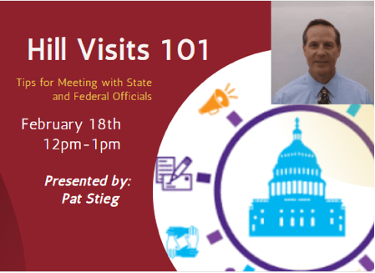

An Update from Advocacy Committee
Chairperson, Derek Hersch announced that MN SOPHE proudly joined Trust for America's Health and more than 300 other organizations in supporting the Improving Social Determinants of Health Act 2021 (S. 104/H.R. 379). This legislation would empower public health departments and community organizations to act as chief health strategists in their communities and lead efforts to convene partners across sectors to build integrated systems.
April 2021 National SOPHE Summit
https://www.sophe.org/professional-development/conferences_events/sophe-2021/
GATEWAY TO THE FUTURE: Health Education and Promotion for All!
Virtual Summit, April 6-9
Check out $50 discounts for national and chapter members

Connect with Coffee Talk Ideas
Staying connected with other professionals during COVID can be a challenge. The Membership and Communication committee would like to establish informal virtual opportunities for our chapter members to meet. The “coffee talk” idea can start with one topic, but emerge to “what’s on your mind?” conversations with your peers. If interested Taylour Blakeman and Cecelia Schaefer would like to hear from you: Contact us at sopheminn@gmail.com

MN SOPHE Board meetings are held the second Friday of the month. If interested in attending, please contact us at sopheminn@gmail.com

Submitted by: Jean Streetar, Secretary

