MN SOPHE
Meeting Agenda/Minutes/Summary

Date: January 8, 2021 | Time: 8:30-10 am
Location: Zoom
Attending: Kelly Kunkel, President; Mary Kramer, President Elect; Cherylee Sherry, Treasurer; Judith Luebke, National Delegate; Taylour Blakeman, Membership chair; Antonia Yenser, Continuing Ed chair; Derek Hersch, Advocacy chair; Cecelia Schafer, Communications chair; Suzanne Driessen, Past President; Sia Xiong and Kayla Rinderknecht, Student Representatives; Jean Streetar, Secretary. Guest: Liz Heimer.
Absent:
Facilitator: Kelly Kunkel | Recorder: Jean Streetar
Meeting Objectives: Welcome new board members and set goals for 2021
Minutes Approved:

Agenda Item | Discussion | Person assigned
Call to order and approve agenda | 2021 President, Kelly Kunkel called the meeting to order at 8:31 am. Welcome to all in this new year. Our country has had a difficult first few days and Kelly reminds us to pause and take care of ourselves as needed.  There was a motion to approve the agenda as sent (motion: Suzanne, second: Judith) approved. | Kelly
Roll call | Roll call taken and all were present. Liz Heimer will be presenting results from the recent membership survey. | Jean
Welcome new board members | Introductions - All  - Please share your name, role on the board, how you touch public health education in your life, and did you make a New Year’s Resolution for 2021, yes or no? (Don’t have to share what it is if yes).
Old Business
Secretary’s report | Approve minutes from December 11, 2020. Jean asked for any feedback on the meeting minutes template. The secretary is also asked to work with membership on new member welcome information. Jean is willing to mention new members in the monthly highlights email. Kelly said a welcome to new members video is being worked on. Motion to approve the December minutes (motion: Suzanne, second: Antonia). Motion approved. Jean will add the approved date to the minutes and send to Taylour for posting on the website. Jean will send out meeting highlights to members. | Jean, Taylour, Kelly
Goals for 2021 Updates and Progress Reports - Review 2020  (carry over) | - Explore scholarship program opportunities for students and professionals –  - Explore process and documents needed for becoming a 501(c)(3) organization  - Explore partnering opportunities with other organizations  - Memorandum of Understanding (MOU) with other organizations  Kelly thanked Suzanne for referencing the 5 year strategic plan for possible additions to our list of goals. Goals can be considered at other times of the year as needed. Additional ideas can be sent to Kelly for consideration. It seems that the three goals above will stand for 2021. Jean will discuss partnering ideas with MN Public Health Association for CHES/MCHES offerings. There is a CDC MOU template that could be used. The partnering agreement would help work out cost and designation of the credits earned for members and participants. As we move forward to be a 501.(c).3 organization we will need to have a mission and vision. Kelly asked for a subcommittee to work on a mission and vision. Judith, Cherylee, Mary, and Sia are interested. | Discussion by all.  Judith, Cherylee, Mary, and Sia
By-Laws | Joe Visker completed the review and edits of the MN SOPHE by-laws last month. Suzanne has sent on to members for a vote to approve. Please vote by Jan 15, 2021. All members are now on the new list serve so they will hear about the request to vote. Suzanne will send a reminder as well. Thanks again to Joe for all of his work and to other board members for their edits and comments.  We have established a new committee for Awards and Recognition under the revised by-laws. Once the by-laws are adopted, we can move ahead with the chair position and members/roles. Cherylee will forward the approved by-laws to the Secretary of State. | Suzanne, Cherylee
New Business
Goals for 2021 | Discussed under Old Business. Kelly would like to have a mid-year look at any revisions or additions to the goals. Kelly is also suggesting a successful summit as another goal for the chapter in 2021. | Kelly
Member survey results | The membership survey was sent out in December to 350 names on the list of members, CHES certified, and participants in MN SOPHE events. There were 32 responses. Of those responses 59% were members. A majority were not CHES or MCHES and a majority were either full time professionals or full time students. There was a wealth of information drawn from the survey for continuing ed ideas, valuable activities, communications and other. The need for networking and connecting seems to be an overall theme. A drawing was held for a $20 Caribou gift card. Liz will provide a brief overview of results and post the survey on the website. Jean will include in the Jan meeting highlights. Cecelia can use results information for Facebook posts. Others were interested in establishing an informal virtual networking meeting for all members.  Thanks Liz, for doing the survey and providing the overview! | Liz, Jean, Cecelia
New Resolution | Derek made a motion for the board to accept the Resolution on Ending the Sale of Flavored Tobacco Products. Cherylee seconded the motion. Derek also thanked Liz for bringing this issue forward for advocacy by our chapter. As a result of this work, MN SOPHE is now a member of the MN Smoke Free Generation. A notice will be sent to members and the resolution will be posted on the website. | Derek
Officer and Committee Reports
President-Kelly | Next meeting will be February 12 at the regular 10 am time. No further updates.
Past President-Suzanne | Past-president is the liaison with student reps and Suzanne would like to set up a time to meet with Sia and Kayla for orientation. | Suzanne, Sia, Kayla
President elect-Mary | Looking forward to planning the 2021 summit (hopefully an in person event?). Meetings to begin February or March.
Student representatives-Sia, Kayla | No updates at this time.
Treasurer-Cherylee | The year-end treasurer’s report was sent with a balance of $6,905.39. There is one outstanding summit check to be cashed. Regular expenses reported for January along with the $20 Caribou gift card for the survey drawing. The chapter increased its funds by about $2,000 this year mostly due to having a virtual summit. To consider a 2021 budget, Cherylee recommends setting aside $750 for the filing of a 501.(c).3 form. If the summit is held in person, there will be additional expenses. The awards for 2020 were just over $200. If National conferences go back to in person meetings, line items for travel can be considered. Kelly asked committee chair persons to review their plans and submit any anticipated budget need to her by the February monthly meeting. | Cherylee, Kelly
Advocacy-Derek | The tobacco resolution was approved. Derek is developing a legislative priority list and drawing from various resources.
Communications-Cecelia | Working on a member recruitment plan for this year. Facebook messaging will include member survey information and ideas for member networking.
Continuing Ed-Antonia | The first webinar for the year will be related to tips for meeting with elected officials featuring Patrick Stieg (previous advocacy chairperson). Save the date for February 18, 2021 at noon. Antonia would like to host a webinar every other month in 2021. She is also interested in looking at the member survey responses for additional ideas and committee building.
National Delegate-Judith | The National meeting will be held Monday, January 11, so no new updates at this time
Membership-Taylour | A report was sent to the board: 78 member-44 professional and 34 students. Working with communications on recruitment plans; reviewing member survey for ideas; and ongoing webpage updates.
Good of the Order | Derek is looking for advocacy committee recruitment in the coming year.
Adjournment | The meeting was adjourned at 9:53 am
Next meeting | Friday, February 12, 2021 10-11:30 am on Zoom
Submitted by: Jean Streetar

Meeting Summary:

Welcome new MN SOPHE Board
Kelly Kunkel, President; Mary Kramer, President Elect; Cherylee Sherry, Treasurer; Judith Luebke, National Delegate; Taylour Blakeman, Membership chair; Antonia Yenser, Continuing Ed chair; Derek Hersch, Advocacy chair; Cecelia Schafer, Communications chair; Suzanne Driessen, Past President; Jean Streetar, Secretary
Special welcome to the newly appointed Student Representatives: Sia Xiong, a graduate student at St. Catherine’s University and Kayla Rinderknecht, undergrad at Minnesota State University-Mankato.

All Members: Vote to Approve Chapter By-Laws
The MN SOPHE Board of Officers has, as required under Article X, Section 2 of the MN SOPHE by-laws, conducted the bi-annual review of the chapter by-laws. Before the new by-laws can be formally adopted, under Article X, Section 3 of the MN SOPHE by-laws, the new by-laws must be brought to the general membership for a vote.
Please take a moment to review the proposed by-laws at https://drive.google.com/file/d/1Js3TGIUs73NmEQBFjJE_MKB8fTPwqb9L/view?usp=sharing.
Once you have reviewed the proposed Bylaws, please cast your vote by January 15, 2021 at: https://mnsu.co1.qualtrics.com/jfe/form/SV_9p1gTRVgDmL8iRD
Please contact Dr. Joe Visker (joseph.visker@mnsu.edu) if you have any questions or concerns.

Thank You for Completing the Member Survey!
Valuable information was provided by members to help shape future work of the MN SOPHE chapter. Here is snapshot of the results. Full results can be reviews at: https://mnsophe.wildapricot.org/2020-MN-SOPHE-Survey
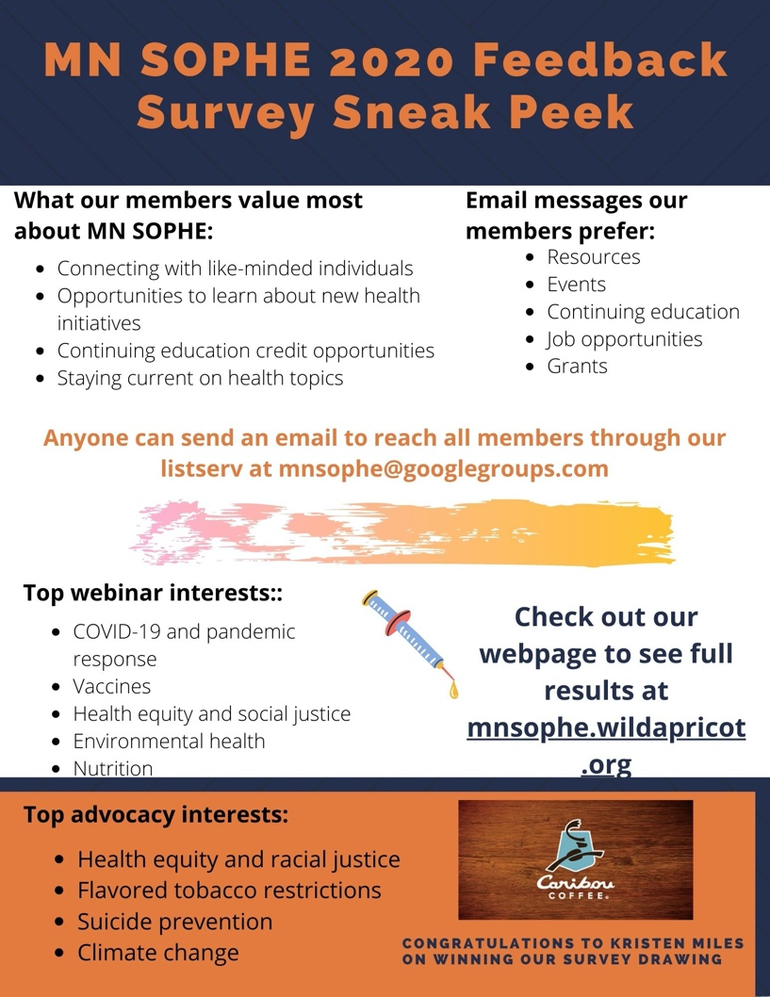

NEW MN SOPHE Resolution
The MN SOPHE Board of Directors voted in favor of adopting the Resolution on Ending the Sale of Flavored Tobacco Products. The resolution calls for advocacy, health education and promotion activities directed to end the sale of flavored tobacco products. The newly adopted resolution is posted on the chapter website:
https://mnsophe.wildapricot.org/Advocacy
For more information on this issue, please check out the recording of the webinar MN SOPHE hosted back in September: Flavored Tobacco: A Social Justice Issue in Minnesota.
Aligned with this resolution, MN SOPHE has become a member of Minnesotans for a Smoke-Free Generation - a coalition of over 50 organizations, with a goal of reducing youth tobacco use.
If you're interested in getting involved in MN SOPHE's future advocacy efforts, including the creation of our 2021 legislative priorities, please contact me at: derekherschmsp@gmail.com.

Save the Date: MN SOPHE Webinar Feb 18
The first webinar for the year hosted by MN SOPHE will focus on “tips for meeting with elected officials” and will feature Patrick Stieg (previous chapter advocacy. Save the date for February 18, 2021 at noon. CHES and MCHES credits will be offered FREE to members. Watch for more details in your emails.

MN SOPHE Board meetings are held on a monthly basis. All members are welcomed to join in the Zoom calls. The next meeting is scheduled for February 12, 2021. Contact Kelly Kunkel, President for more information at sopheminn@gmail.com

